

American International University-Bangladesh (AIUB)  
**Department of Computer Science  
Faculty of Science &Technology (FST)**

**Instant Utilities Service Provider**

A Software Requirement Engineering Project Submitted

By

|  |  |  |  |  |
| --- | --- | --- | --- | --- |
| **Semester: Spring_22_23** | | **Section: C** | **Group Number: 9** | |
| SN | Student Name | Student ID | Contribution (CO1+CO2) | Individual Marks |
| 1 | Ishrat Jahan | 18-36147-1 |  |  |
| 21 | Anik Das | 19-41048-2 |  |  |
| 25 | Sayeda Tasneem Nova | 19-41423-3 |  |  |
|  |  |  |  |  |
|  |  |  |  |  |

The project will be Evaluated for the following Course Outcomes

|  |  |  |
| --- | --- | --- |
| Evaluation Criteria | Total Marks (50) | |
|  | |
| Introduction, Format, Submission, Defense | [10 Marks] |  |
| System Overall Description & Functional Requirements | [10 Marks] |  |
| System Quality Attributes and Project Requirements | [10 Marks] |  |
| UML and E-R Diagram with Data Dictionary | [10 Marks] |  |
| UI/UX Prototyping | [10 Marks] |  |

Software Requirements Specification

for

Instant Utilities Service Provider

Version 1.0 approved

Prepared by

Ishrat Jahan, Anik Das and Sayeda Tasneem Nova

American International University - Bangladesh

22nd April 2023

Table of Contents

Revision History 3

1. Introduction 4

1.1 Purpose 4

1.2 Document Conventions 4

1.3 Intended Audience and Reading Suggestions 4

1.4 References 4

2. Overall Description 4

2.1 Product Perspective (Business Requirements) 4

2.2 Product Functions 5

2.3 User Classes and Characteristics 5

2.4 Operating Environment 5

2.5 Design and Implementation Constraints 5

2.6 User Documentation 5

3. System Requirements 6

3.1 System Features 6

3.2 Non-Functional/Quality Requirements 6

3.3 Project Requirements 6

4. Interface Requirements 7

4.1 UML 7

4.2 Data Dictionary 7

4.3 UI/UX Design Specification 7

# Revision History

|  |  |  |  |
| --- | --- | --- | --- |
| **Name** | **Date** | **Reason for Changes** | **Version** |
|  |  |  |  |
|  |  |  |  |

# Introduction

## Purpose

The “Instant Utilities Service Provider” software system will address the need and urgency of utilities services and repairs for customers in their area, such as water, electricity, gas etc. and will be used by utilities service companies. This is the initial version of the document, version 1.0.

**Product scope:** The utilities service provider system will allow the customer to request for utilities services eg: plumbing, and will display a list of service providers that are available nearby the customer’s location for that particular service. The customer would choose the service worker depending on their area of proximity, service ratings and reviews and fare range before placing their order. The service provider concerned would then track the customer’s location to carry out the request after brief communication with the customer.

The purpose of the “Instant utilities service provider” is to deliver utilities services for customers who don’t have direct access to them in their area of residence and they are facing many problems, such as a power outage, water pipe leakage etc., because of it. With this system, the service will instantly be delivered by an expert technician instead of commuting far from home, office or any other institution to a utility company, thus saving time and money. The system would promote more customer engagement through help desks where communication between customer and employee takes place or with the help of community forums, user ratings and reviews the quality of services could potentially improve day by day. As a result, not only customers would be satisfied but also the company that uses this website would be rewarded with a gradual rise in sales and revenue.

## Document Conventions

* Text Format: IEEE Format
* Text Font: Times New Roman
* Text size: 12
* Line Spacing: 1.0
* Alignment: Justify
* Red color text: Multivalued Attribute (refer to section 4.2: Data dictionary)
* Italicized text: To emphasize each reference
* For section 3.1, under System Requirements, the functional requirements are ordered by hierarchical numbering, for eg: 1.1, 2.3 etc. and 1.1.1, 1.7.3 etc. were used to indicate child requirements of that requirement.
* For section 3.1, under System Requirements, the non-functional requirements are ordered by sequence numbering, such as QA1, QA4 etc.
* [] were used to state the priority of a detailed requirement that did not inherit the priority of its higher-level requirement.

WBS – Work Breakdown Structure

## Intended Audience and Reading Suggestions

This document is to be read by the following audience who might review the document learn about the project and to gain a clear understanding of the requirements.

* + **Project managers** who base their estimates of schedule, effort, and resources on the requirements, may refer to section 3.3 for project requirements.
  + The **marketing staff** who need to know what product they can expect to be delivered, would refer to section 2.1 to section 2.5 to become familiar with the various product functions in order to effectively advertise this product.
  + **Development teams** who need to know what to build, may refer to section 2.3, 2.5 for knowing on which operating environment they will use, as well as the design and implementation constraints that would be met, and sections 3.1 – 3.2 for functional and non-functional requirements.
  + **Testers** who would use it to develop requirements-based tests, test plans, and test procedures may refer to section 3.1-3.2 to gain understanding of the system features to develop meaningful test cases and give useful feedback to the developers.

## References

<https://www.inmyarea.com/utilities>

<https://www.toaks.org/residents/utilities/utility-service-providers>

# Overall Description

## Product Perspective

* The “Instant utilities service provider” system will reduce the customer support staff costs by 30% when customer uses the help desk page to interact effectively with the service provider or support staff.
* The system will have a GPS interface that will allow the service provider to track the customer’s location thus reducing the transportation and delivery costs to a minimum if the customer is nearby.
* With increasing customer-staff involvement through the system through the help desk and customer feedback of the service’s quality assurance, the sales and revenue of the company using it, will rise by 40%.

People who do not have direct access to important utilities in their area encounter many difficulties, such as a power outage, water pipe leakage etc., which adversely affects their daily routine. Homes that are prone to such problems suffer huge property damage and incur financial crisis. Furthermore, incidents such as a minor gas leak, or an electric discharge could lead to a devastating explosion if they are not handled at once. Travelling long distances to get to a utility service company for a service is another inconvenience and the utilities issue would only be delayed further. Therefore, an “Instant Utilities Service Provider” system would easily solve the aforementioned problems, with on-time service delivery and quality assurance from service providers available within a customer’s area of residence.

## Product Functions

The major functions the utilities service provider must perform or must let the user perform include:

* User Login
* User signup for Customer and Service Provider
* Service order from Customer and delivery from nearest service provider
* Customer’s location tracking
* Payment transaction between Customer and Service provider
* Work order status update

## User Classes and Characteristics

The utilities service provider system will have three types of users: Customers, Service Providers and Admin. The system will mainly be used for customers as they are the ones who would request for services from service providers, whose functionality is to deliver service orders. Finally, admin will track the status of work orders of the service providers. While the Admin and Service provider users are both corporate employees working for a utilities service company with technical education levels, the customer could also be an office worker or “stay-at-home” parent who might be familiar with the system.

A customer:

* Creates an account and logs in
* Searches for services
* Selects the nearest service provider in their location
* Fixes schedule for service delivery
* Pays either online or cash on delivery

An admin:

* Approves service providers signup requests
* Generates unique User ID for each class of users
* Adds service providers to database
* Notifies service providers of service order requests.
* Tracks work order status.

A service provider:

* Requests for Signup
* Views customer orders
* Sorts them by earliest date and time
* Tracks the location of the customer
* Updates work order status

## Operating Environment

The system shall be developed in a web-application environment, using web technology languages such as HTML, PHP, CSS and JavaScript using Visual Studio Code and Microsoft SQL server for database connection. It will run on Windows and will support versions 7, 8, 10 and 11. Hardware requirements include a PC with 8GB RAM and 256 GB of Hard Disk Space for development.

## Design and Implementation Constraints

* The system is yet to be developed in such a way that it would support mobile operating systems such as Android and iOS.
* The system must have internet connection at all times so that the database is connected.
* The system must provide volume for simultaneous performance and system design should not introduce scalability issues regarding the number of devices connected at any one time.
* The system must be reliable enough so that it resists faults as much as possible, or speed up error recovery time such that the faults are hidden from its end-users.

## User Documentation

* **User manuals:** User manuals provide detailed instructions on how to use the utility service, including step-by-step instructions on how to access and use specific features.
* **FAQs:** Frequently asked questions (FAQs) provide answers to common questions that users may have about the utility service. This can help users troubleshoot issues or better understand how the service works.
* **Help desk support:** Help desk support provides users with access to support staff who can help troubleshoot issues or answer questions about the utility service.
* **Community forums:** Community forums provide a platform for users to connect with each other and share tips, best practices, and solutions to common issues.

# System Requirements

## System Features

**Functional Requirements (FRs)**

* 1. **User Registration**
     1. A user shall register with valid username and password after filling in necessary information such as their name, email, phone number and home address.
     2. If the user is a new service provider, he/she shall also fill in their job description as in what type of service would they provide and their workplace.
     3. Once a service provider has submitted their signup request, he/she shall wait for the admin’s approval for login.
     4. When a user’s account has been created, the user shall have access to their account by logging in with their registered username and password.
     5. A service provider user shall have access to their account only after the admin has approved their signup request by assigning their ID and adding them to the database.

**Priority Level: High  
Precondition:** Fill in required fields, eg: username and password.  
**Cross-references:** 1.2.1**,** 1.6.3, 1.6.4

* 1. **User Login**
     1. The software shall allow users to loginwith their given username and password.
     2. The login credentials will be verified with the database records.
     3. If login is successful the user will be directed to their account profile page.
     4. If user has forgotten their password or entered the incorrect login credentials, the user shall go to another page to enter verification code that will be sent directly by mail or SMS to retry login.
     5. After entering verification code, the system shall allow the user to login successfully but will be asked to reset their password to replace the old one.
     6. The user will be able to access their account the next time they login but with the new password.

**Priority Level: High  
Precondition:** user have valid user id and password  
**Cross-references:** 1.1.4, 1.1.5

* 1. **Customer Profile**
     1. The software will allow the customer to view their profile after successful login.
     2. The software will allow the customer to update their account information if necessary.
     3. The customer shall search for any utility service such as household repairs, electrical repairs etc. through the system.
     4. If the service is available, the system shall display a list of service providers for that service, near the customer’s location.
     5. The customer shall then select the service provider closest to their location for service.
     6. The system will also display the service provider’s information such as their job description, workplace, fare range as well as customer reviews and ratings.
     7. The system can also allow the customer to request for services manually, by entering service details and their location.
     8. After submitting the request, the system will display a message that will ask the customer to wait for 30 minutes while the request is being processed.
     9. After that the customer may receive either a call, an SMS or an email from the service provider and the customer shall provide more details about their required service.
     10. The system will also allow the customer to communicate with a service provider through the help desk where it will have the chat-box and call option. [Priority: Medium]

**Priority Level: High  
Precondition:** Customer have valid user id and password  
**Cross-references:** 1.6.11, 1.7.9, 1.7.10

* 1. **Service Booking**
     1. After selecting the service provider, the customer shall confirm a service order, by setting the scheduled time and date for the service to be delivered and mark their location on the map.
     2. If the customer requests multiple services of the same type at the same time under the same service provider, for eg: leaky sink pipe repair and new sink installation, the system shall add it to the payment bill.
     3. If the customer requests multiple services of different type, eg: leaky pipe repair and internet cable installation, then the customer will select different service providers. The software will add them altogether to the payment bill.

**Priority Level: High  
Precondition:** Customer should select a service provider for service  
**Cross-references:** 1.5.1,1.7.5

* 1. **Payment**
     1. After confirming a service order, the customer will be redirected to the bill page, where the orders will be displayed along with their fixed schedules and the total service charge.
     2. The customer shall select a payment method which is either online payment through visa, Mastercard or MFS (bKash, Nagad, Rocket) or cash on delivery.
     3. The payment credentials (account holder name, account number etc.) will be verified with relevant selected payment method partners database records.
     4. If online payment is successful, then the customer will be alerted with a confirmation message, showing transaction complete.
     5. If the payment is failed due to any sort of issues the user will get maximum 24 hours to complete their payment, otherwise the request will be automatically canceled.

**Priority Level: High  
Precondition:** Customer confirms their service order.  
**Cross-references:** 1.4.1

* 1. **Admin Profile and Functions**
     1. After successful login, the admin will be directed to his/her profile page where their account information is displayed.
     2. The admin will have an option to update their profile information if necessary.
     3. When a service provider requests for sign-up, the admin shall decide to approve their request by assigning their ID.
     4. Once the admin adds the service provider information to the database, the admin shall notify the service provider through their email or SMS.
     5. The system will allow the admin to view service provider information and will also allow the admin to update or delete the user from the database.
     6. The system allows the admin to view all the service order requests from customers and will direct each order request to the selected service provider.
     7. Once the service provider accepts the order request, the admin shall track the status of the order and set it as ‘ongoing’.
     8. If the service provider has delivered the service, the admin shall update it to ‘completed’.
     9. If the customer has cancelled the order request or the concerned service provider has not accepted the order request, then the admin shall set the order status as ‘cancelled’.
     10. The admin shall notify the customer of the status changes through email or SMS.
     11. If the customer chooses to submit a service request through the help desk, the admin shall process this request and deliver a response within 30 minutes. [Priority: Medium]

**Priority Level: High   
Precondition:** Admin must login with valid username and password.  
**Cross-references:** 1.1.2, 1.1.5, 1.3.8, 1.7.3, 1.7.4, 1.7.6, 1.7.8, 1.7.9

* 1. **Service Provider Profile and Functions**
     1. The service provider user will be directed to their profile page where their account information is displayed.
     2. The system will allow the service provider to update their profile information, such as their name or email if necessary.
     3. The system shall allow the service provider to view all the customer’s service orders and sort them by the earliest date and time.
     4. The service provider shall then accept the service order and will notify the customer that the order has been accepted.
     5. The service provider shall then track the customer’s location through a GPS system eg: Google Maps.
     6. Once the service order is complete, the service provider will set the order status as ‘complete’ upon receiving payment.
     7. If the service provider has yet to complete the work order, he/she shall schedule the work order for another time depending on the customer’s urgency and convenience; The work status shall then be set to ‘postponed’.
     8. If the work order request has been cancelled then the work status shall be set to ‘cancelled’ and the service provider shall accept the next incoming order.
     9. If the customer has submitted a service request through the help desk, then a service provider shall choose to accept the request if the admin has notified them.
     10. The service provider shall then either call the customer or notify them via email or SMS and ask for more details about the customer’s service order.

**Priority Level: High   
Precondition:** Service Provider must login with valid username and password.  
**Cross-references:** 1.3.7, 1.3.9, 1.3.10,1.4.1, 1.6.6, 1.6.7, 1.6.8, 1.6.9

## Non-Functional/Quality Requirements

**QA1:** **Usability:** The User Interface should be simplistic and easy enough for a user to navigate and get a good understanding of the relevant information with clear instructions and eye-catching design.

**Priority Level: Medium**

**Cross Reference: N/A**

**QA2:** **Efficiency:** The performance time shall be low when returning the search results (less than 2 seconds.)

**Priority Level: High**  
**Cross-references:** **N/A**

**QA3:** **Compatibility:** The website running on eg: Chrome browser must be able to run on other browsers, such as Firefox, Safari, Opera etc. without any changes in its behavior and efficiency.

**Priority Level: High**  
**Cross-references: QA2**

**QA4: Portability:** The system will be supported on Windows as well as macOS and shall also support other versions such as Windows 7, 8, 10, 11 and macOS 11, 12, 13.

**Priority Level: High**  
**Cross-references: N/A**

**QA5:** **Scalability:** The website shall be designed in such a way that it will be able to handle increasing traffic and usage overtime without compromising its efficiency or reliability.

**Priority Level: High**  
**Cross-references: QA2, QA6**

**QA6:** **Security:** The system would allow access only to registered users, with a strong password that follows proper format (see section 4.2) to prevent external hacking attacks. The system shall automatically logout after 3 minutes by employing user cookies.

**Priority Level: High**  
**Cross-references: N/A**

**QA7: Availability:** The system shall be available to the users 99.98% every month during business hours, unless maintenance is required.

**Priority Level: High**  
**Cross-references: QA7**

**QA8: Reliability:** The system will perform with minimal downtime (less than 5%) for maintenance.

**Priority Level: High**  
**Cross-references: QA4**

**QA9:** **Maintainability:** System must be easy to upgrade and maintain. The mean time to restore the system must not be more than 10 minutes.

**Priority Level: High**  
**Cross-references: QA6**

## Project Requirements

* **Testing Tools:** The system developer shall need selenium tools in perform testing activities.
* **Project Management Tool:** A WBS shall be used to divide the project into subprojects, further divided into activities and tasks, using Microsoft Project.
* Activity planning, resource allocation, effort estimation and risk management will also be performed with the help of Microsoft Project or JIRA.

# Design and Interface Requirements

## UML Diagrams

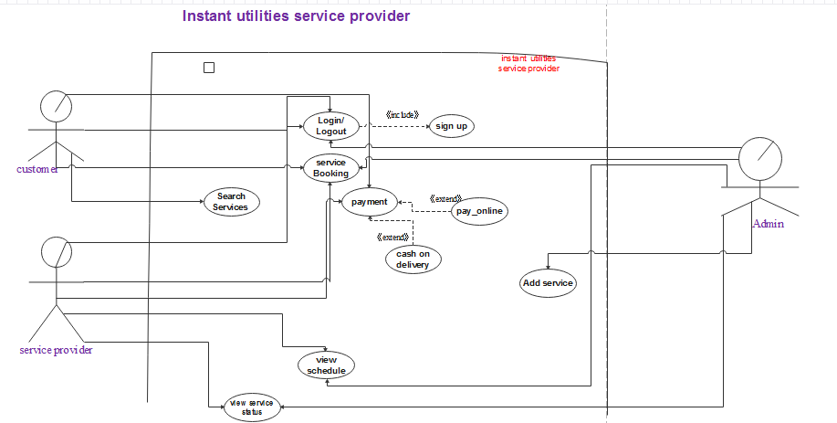

**Figure 1.1**: Use Case Diagram

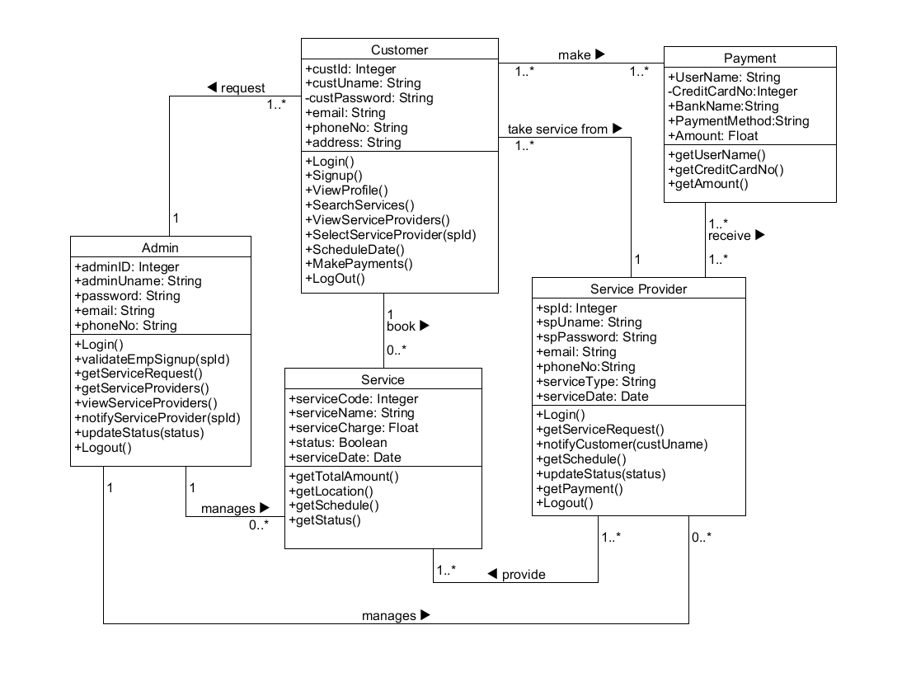

**Figure 1.2**: Class Diagram

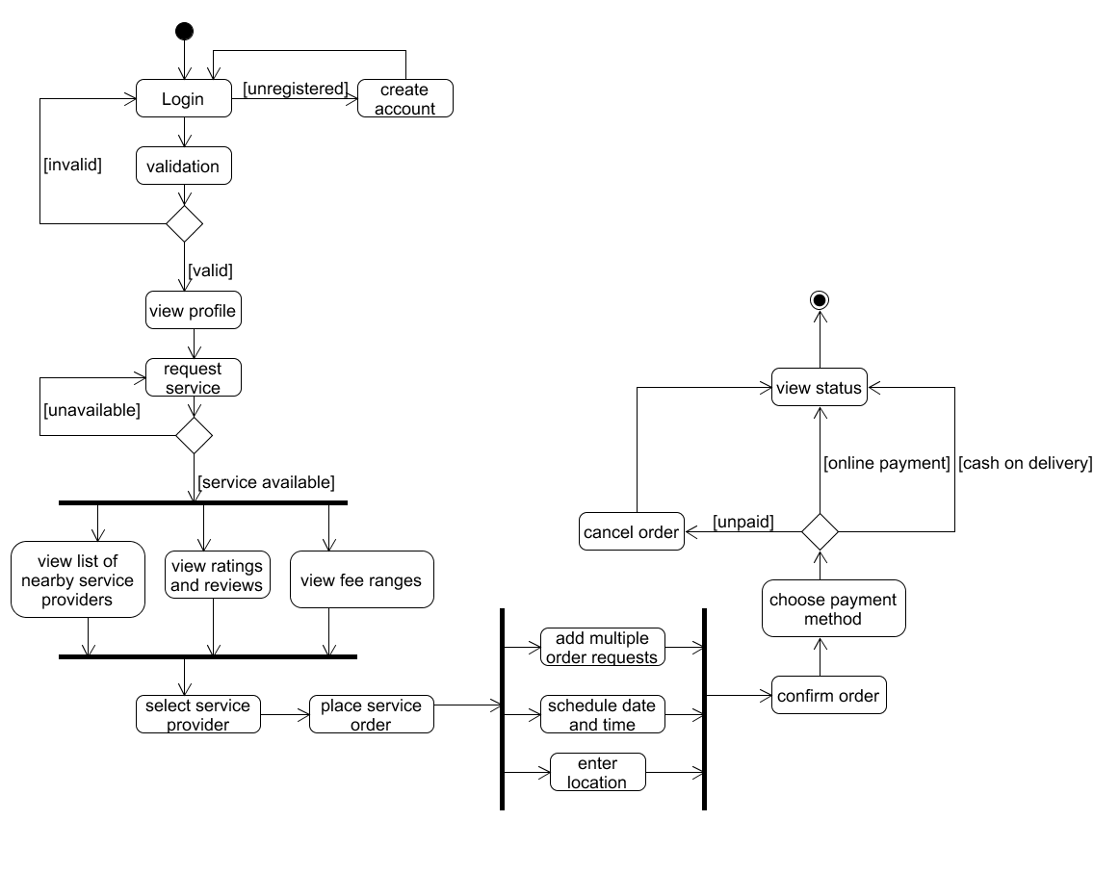

**Figure 1.3:** Activity Diagram for Customer Activities

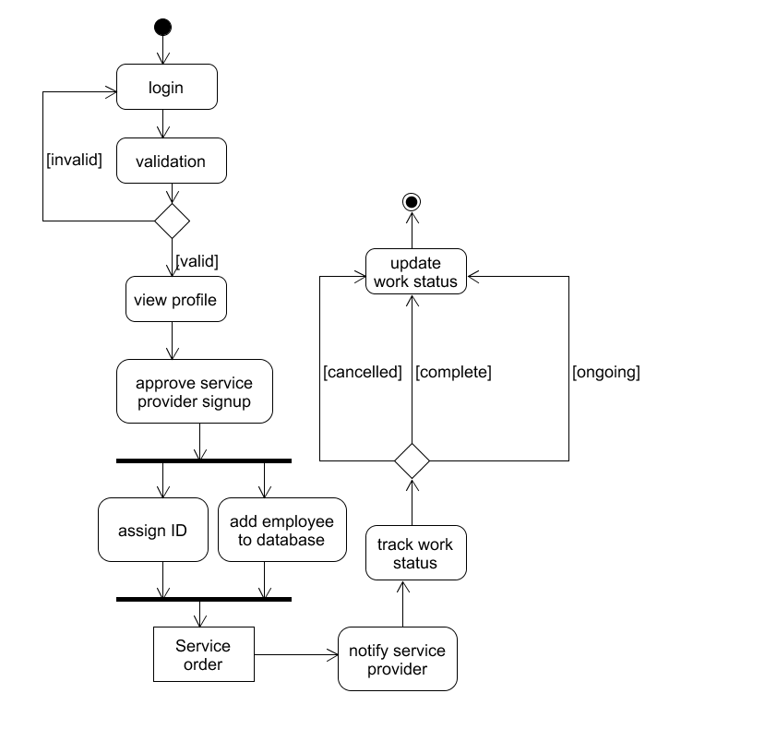

Figure: Activity Diagram for Admin Activities

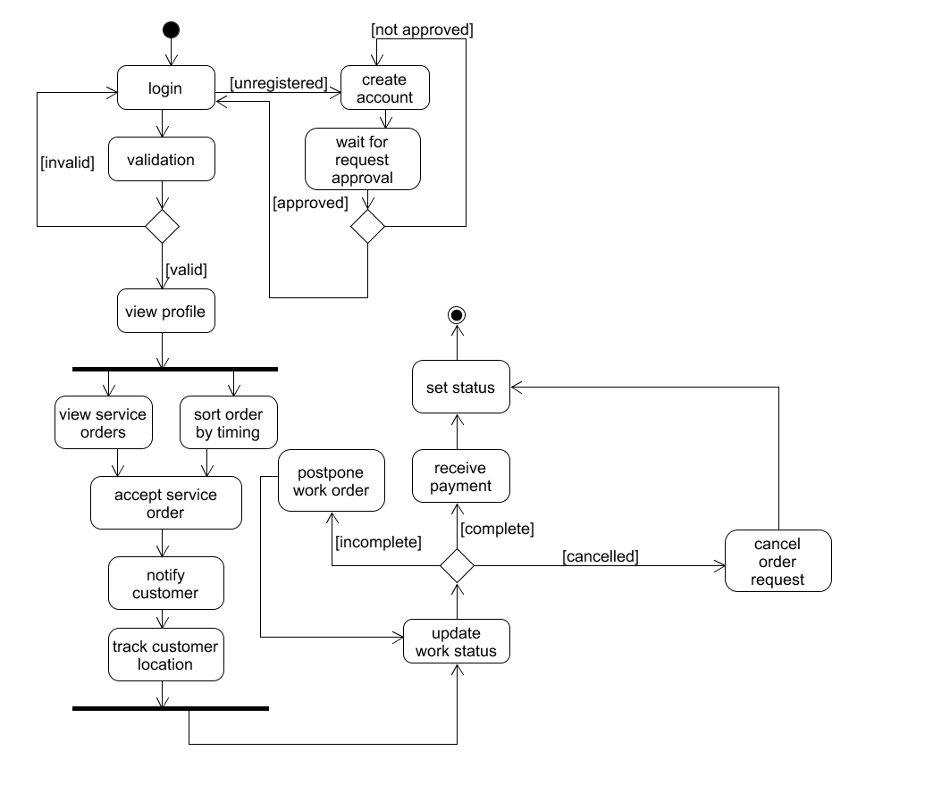

**Figure 1.4:** Activity diagram for service provider activities

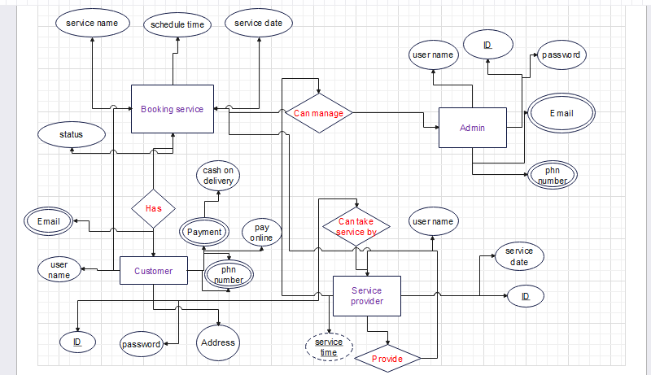

**Figure 1.5:** ER diagram

## Data Dictionary

|  |  |  |  |  |
| --- | --- | --- | --- | --- |
| **Entity** | **Attribute** | **Type/Size** | **Validation** | **Key** |
| Customer | c_Id | Number (10) | 10000-99999 | Primary |
| Customer | c_uname | Varchar (50) | Required  Must contain upper case, lower case, numbers, underscores and dots.  No special characters allowed |  |
| Customer | c_pass | Varchar (20) | Required  Must not be less than 8 characters.  Must have an uppercase letter, lowercase letter and a special character. |  |
| Customer | c_email | Varchar (50) | Required |  |
| Customer | c_phn | Varchar (10) | Required | Unique |
| Customer | c_address | Varchar (50) | Required |  |
| Admin | a_Id | Number (10) | 10000-99999 | Primary |
| Admin | a_pass | Varchar (20) | Required  Must not be less than 8 characters.  Must have an uppercase letter, lowercase letter and a special character. |  |
| Admin | a_email | Varchar (50) | Required |  |
| Admin | a_phn | Varchar (10) | Required | Unique |
| Admin | a_uname | Varchar (50) | Required  Must contain upper case, lower case, numbers, underscores and dots.  No special characters allowed |  |
| Service Provider | s_id | Number (10) | 10000-99999 | Primary |
| Service Provider | s_uname | Varchar (50) | Required  Must contain upper case, lower case, numbers, underscores and dots.  No special characters allowed |  |
| Service Provider | s_pass | Varchar (50) | Required  Must not be less than 8 characters.  Must have an uppercase letter, lowercase letter and a special character. |  |
| Service Provider | s_email | Varchar (50) | Required |  |
| Service Provider | s_phn | Varchar (10) | Required | Unique |
| Service Provider | service_type | Varchar (50) | Required |  |
| Service Provider | service_date | Date (8) | ‘DD/MM/YYY’  Format |  |

## UI/UX Design Specification

* **Adobe Illustrator** was used to design the UI/UX design prototype.

